

# Nokia 5710 XA 4G

## Type of device: Mobile

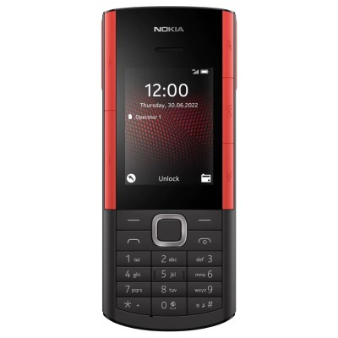

Actual Display Size : 2.4 inches

Button Type : Physical Keypad

Network Capability : 3G,4G

Year of Release : 2022

Average Price : $149 as of 22 11 2022

Other : Unisoc T107

## Accessibility Features:

### Cognitive

* GPS
* Photo Telephone List
* Simple Reminders

Voice Notes

### Hearing Impairment and Deaf

* Bluetooth or Wi-Fi
* Text Messaging/SMS
* Vibrating Alerts - Adjustable

Visual Alerts - Incoming Calls

### Vision

* Battery Alert - Audible
* Bluetooth or Wi-Fi
* Brightness Adjustable
* Key Marker – Raised '5'
* Key Numbers - Standard Layout
* Key Press - Vibration or Click

Personalised Shortcuts

### Speech

* Bluetooth or Wi-Fi
* Messaging Options - MMS
* Predictive Text

SMS Personalisation and Reuse

### Physical

* Automatic Answer
* Bluetooth or Wi-Fi
* Guarded/Recessed Keys
* Physical Dialling Keys
* Predictive Text

Speaker-phone option

## How and where to get it from?

You can buy this phone from [JB Hi-Fi](https://www.jbhifi.com.au/search?page=1&query=nokia%205710%20xa&saleItems=false&toggle%5BonPromotion%5D=false), [Big W](https://www.bigw.com.au/search?text=nokia+5710+xa), [Nokia](https://au.mobileshop.nokia.com/a/feature-phones/nokia/nokia-5710-xa/100000156?variant_id=314&gclid=Cj0KCQiA4OybBhCzARIsAIcfn9lgiIuHCILTM42UU5EV24FaNBmll3UQr1xWyCwAQUgwo56D_ymM7icaAth4EALw_wcB&gclsrc=aw.ds), and other retailers.

## More information is available on:

[Nokia 5710 XA 4G PDF webpage](https://www.nokia.com/phones/en_au/nokia-5710-xpress-audio?sku=16AQUB21A09)

[Nokia 5710 XA 4G PDF User Guide webpage](https://www.nokia.com/phones/en_gb/support/api/pdf/aquila-user-guide)